

International School

CAPSTONE PROJECT 1
CMU-SE 450
USER INTERFACE DESIGN DOCUMENT
Clinic Booking
Clinic Booking and Management System using Chatbot and Voice Assistant
Submitted by: C1SE.62

User Interface Design Review Panel Representative:
Name: Signature Date
Capstone Project 1- Mentor:
Name: Msc.Nguyen Trung Thuan Signature Date

PROJECT INFORMATION

Project acronym | CB
Project Title | Clinic Booking
Start Date | September 6, 2024 | End Date | December 20,  2024
Lead Institution | International School, Duy Tan University
Project Mentor | Msc.Nguyen Trung Thuan
Scrum master  / Project Leader & contact details | Doan Hoang Quan  Email : quandoan.140203@gmail.com Tel: 0905413819  ID: 27211242264
Partner Organization | Duy Tan University
Team members | Name | Email | Tel
27211248324 | Manh, Vo Van | vanmanh23012003@gmail.com | 0905118140
27211242264 | Quan, Doan Hoang | quandoan.140203@gmail.com | 0905413819
27211201526 | Lich, Huynh Ngoc | huynhngoclich10052003@gmail.com | 0935513362
26201241995 | Vy, Nguyen Yen | vyzit112002@gmail.com | 0775513141
27211221365 | Kien, Tran Trung | trantrungkien6@dtu.edu.vn | 0368313577

Document History
Version | Date | Comments | Author
V1.0 | 15 Oct 2024 | Draft for comment | Tran Trung Kien
V1.1 | 30 Oct 2024 | Update | Tran Trung Kien

Table of Contents
- Introduction 4
  - Purpose 4
  - Scope 4
- Describe User Interface Application in Detail 4
  - UI- Clinic Booking -Online clinic booking system. 4
    - UI-01: Home Page 4
    - UI-02: Login 5
    - UI-03: Register 6
    - UI-04: Book an Appointment. 7
Figure 4: Book an Appointment. 7
    - UI-05: Information of doctor. 9
    - UI-06: Profile Settings 10
    - UI-08: Chat & Chatbot 13
    - UI-09: Dashboard (Doctor). 14
    - UI-010: Dashboard (Admin). 15
    - UI-013: User account management (Admin). 16
    - UI-014: Doctor management (Admin). 17
    - UI-016: Add Medicine (Doctor). 20

Figure

Figure 1: Home Page 4
Figure 2: Login 5
Figure 3: Register 6
Figure 5: Information of Doctor 9
Figure 6: Profile Settings 10
Figure 7: Change Password 12
Figure 8: Chat & Chatbot 13
Figure 9: Dashboard (Doctor). 14
Figure 10: Dashboard (Admin). 15
Figure 11: User account management (Admin). 16
Figure 12: Doctor management (Admin). 17
Figure 13: Add department (Admin). 18
Figure 14: Add Medicine (Doctor). 20

Table
Table 1: Home Page 5
Table 2: Login 6
Table 3: Register 7
Table 5: Information of doctor 10
Table 6: Profile Settings 12
Table 7: Change Password 13
Table 8: Chat & Chatbot 14
Table 9: Dashboard (Doctor). 15
Table 10: Dashboard (Admin). 16
Table 11: User account management (Admin). 17
Table 12: Doctor management (Admin). 18
Table 13: Add department (Admin). 19
Table 14: Add Medicine (Doctor) 20

- Introduction
  - Purpose
- This document serves the purpose of specifying application’s UI design
  - Scope
- Create complete interfaces, and describe them clearly.
- Overview of the stages and modules of the system
- Describe User Interface Application in Detail
  - UI- Clinic Booking -Online clinic booking system.
    - UI-01: Home Page
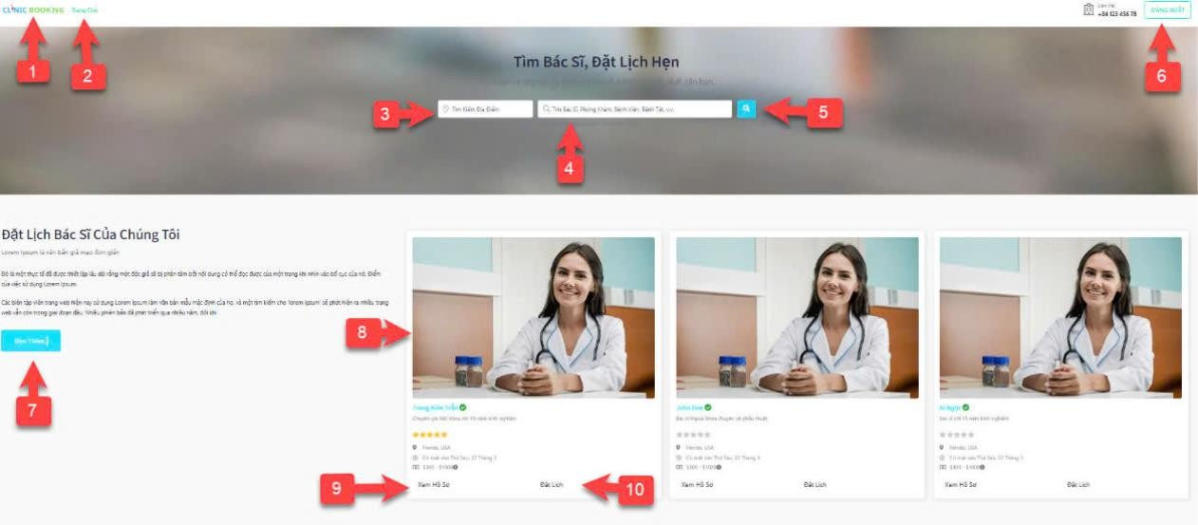

Figure 1: Home Page

ID | Condition | Control Type | Target | Notes
1 | Click | Text | Return to home page
2 | Click | Text | Introduction to the website
3 | Click | Textbox | Input location
4 | Click | Textbox | Input keywords.
5 | Click | Icon | Search button
6 | Click | Icon | Login/logout button

7 | Click | Button | View more catalog
8 | Click | Picture | View doctor profile
9 | Scroll | Text | View doctor details
10 | Click | Button | Book appointment

Table 1: Home Page

    - UI-02: Login

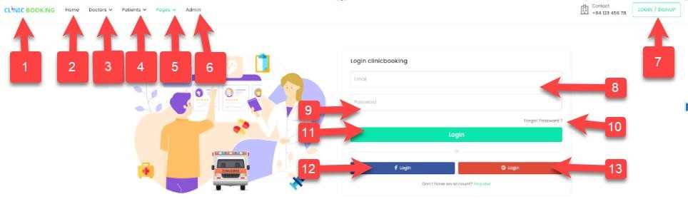

Figure 2: Login

ID | Condition | Control Type | Target | Notes
1 | Click | Menu Button | Home | Navigate to the homepage.
2 | Click | Menu Button | Doctors | View the list of doctors.
3 | Click | Menu Button | Patients | View the list of patients.
4 | Click | Menu Button | Pages | Access additional pages. (Requires more specific pages for effective testing.)
5 | Click | Menu Button | Admin | Access the admin panel.
6 | Click | Link/Button | Login/Sign up | Navigate to login or signup screen.
7 | Input | Textbox | Email | Input email for login.
8 | Input | Textbox | Password | Input password for login.
9 | Click | Link | Forgot Password? | Navigate to the password recovery page.

10 | Click | Button | Login | Login to the system.
11 | Click | Button | Register | Redirect to the registration page.

    - UI-03: Register
Table 2: Login

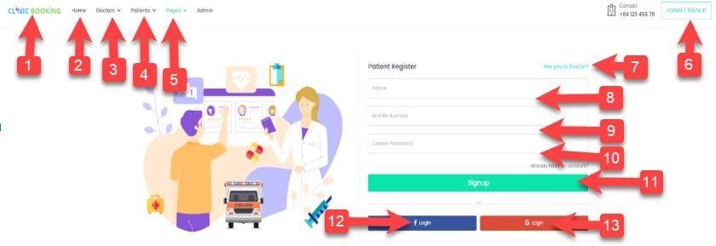

Figure 3: Register

ID | Condition | Control Type | Target | Notes
1 | Click | Menu Button | Home | Navigate to the homepage.
2 | Click | Menu Button | Doctors | View the list of doctors.
3 | Click | Menu Button | Patients | View the list of patients.
4 | Click | Menu Button | Pages | Explore other pages (This needs more specific targets for better testing).
5 | Click | Menu Button | Admin | Access the admin panel (Requires authentication/authorization checks).
6 | Click | Link/Button | Login/Signup | Navigate to the login or signup screen.
7 | Input | Textbox | Name | Input the patient's/user's name. Include tests for valid and invalid input.

8 | Input | Textbox | Mobile Number | Input the patient's/user's mobile number. Include tests for valid and invalid formats.
9 | Input | Textbox | Password | Set a password for the patient/user. Include tests for password complexity requirements.
10 | Click | Checkbox | Doctor | Select if the user is a doctor.
11 | Click | Button | Signup | Register the patient/doctor account. Include tests for success and failure scenarios.
12 | Click | Button | Login | Login to the system. Include tests for success and failure scenarios (incorrect credentials).
13 | Click | Button | Logout | Logout from the system.

Table 3: Register

    - UI-04: Book an Appointment.
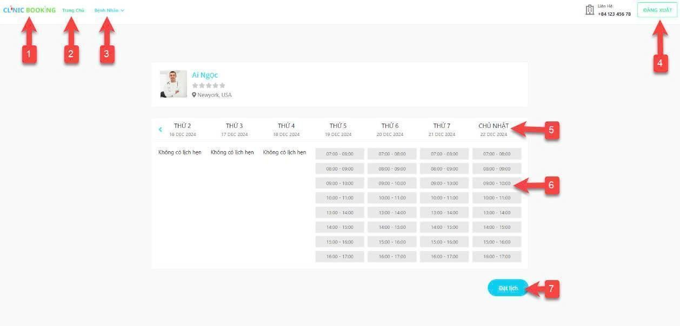

Figure 4: Book an Appointment.
ID | Condition | Control Type | Target | Notes

1 | Click | Menu Button | Home | Navigate to the homepage. Verify page title, main content, and  navigation elements.
2 | Click | Menu Button | Departments | Navigate to the department section. Verify the presence of department names and navigation elements
3 | Click | Menu Button | Patients | View and manage patient information. Verify features for viewing, adding, editing, deleting  patients (if applicable).
4 | Click | Button | Logout | Log out of the system. Verify that the user cannot access restricted areas  after logout.
5 | View | Calendar | Days | View available dates for appointments. Check for correct  display of the current month, navigation to previous/next months, highlighting of booked days, and overall visual clarity.
6 | Select | Button/Timeslot | Appointment Times | Select a specific time for booking. Select various timeslots (morning, afternoon, full day) and test different  booking scenarios. Verify correct selection handling.
7 | Click | Button | Book Appointment | Confirm and book the selected timeslot. Verify that the appointment is correctly added to the system, with  accurate details

Table 4: Book an Appointment.

    - UI-05: Information of doctor.
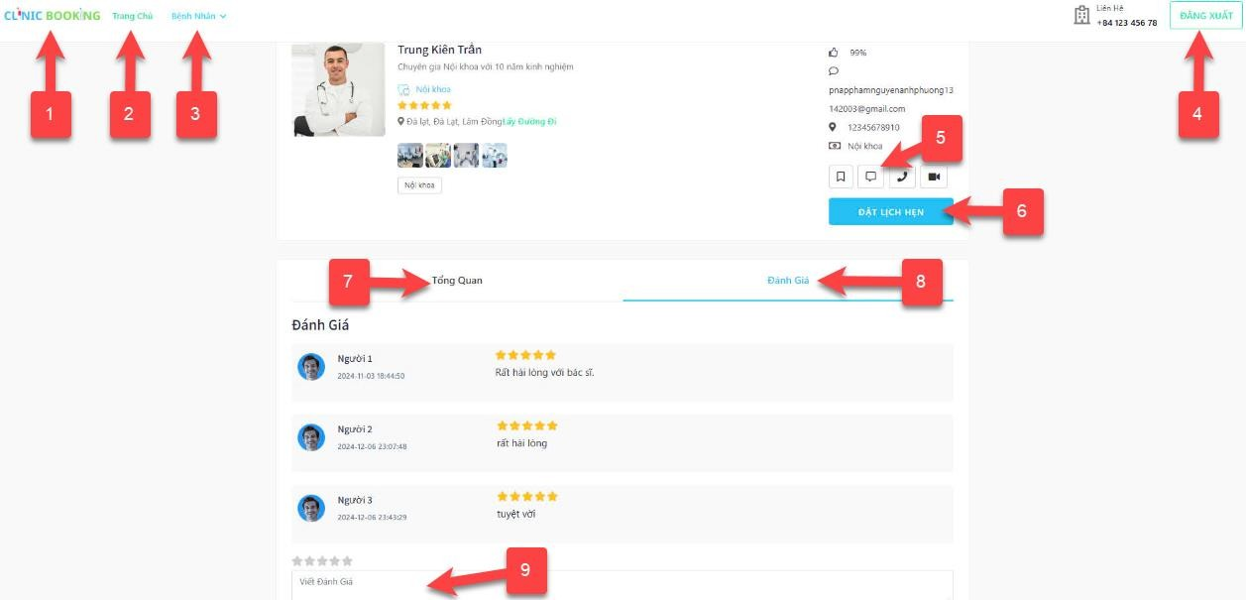

Figure 5: Information of doctor

ID | Condition | Control Type | Target | Notes
1 | Click | Button | Home | Navigate to the homepage.
2 | Click | Button | Home | Navigate to the homepage.
3 | Click | Menu Button | Patients | View and manage patient information.
4 | Click | Button | Logout | Log out of the system.
5 | View | Doctor Profile | Profile Information | Display doctor details and information.
6 | Click | Button | Book Appointment | Schedule an appointment with the doctor.
7 | Click | Tab | Overview | Switch to the Overview tab.

8 | Click | Tab | Reviews | Switch to the Reviews tab.
9 | Click | Button | Write a Review | Write a review for the doctor.

Table 5: Information of doctor

    - UI-06: Profile Settings
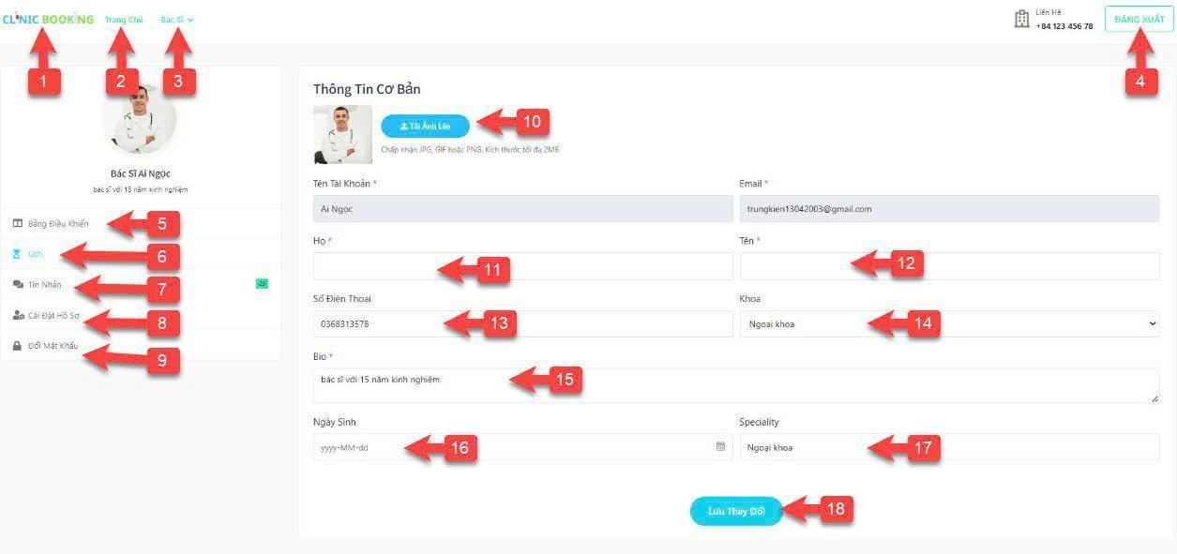

Figure 6: Profile Settings

ID | Condition | Control Type | Target | Notes
1 | Click | Menu Button | Home | Navigate to the homepage; verify page title, main content, and navigation elements.
2 | Click | Menu Button | Departments | Access the department section; verify department list is displayed, check for search/filtering functionality if available.
3 | Click | Menu Button | Doctors | View or manage doctor profiles; verify ability to view doctor details, edit profiles (if

 |  |  |  | permitted), add new doctors (if permitted).
4 | Click | Button | Logout | Log out of the system; verify redirection to login page and inability to access restricted areas after logout.
5 | Click | Menu Button | Dashboard | Navigate to the dashboard; verify dashboard elements and information displayed.
6 | Click | Menu Button | Schedule | View and manage the schedule; verify ability to view appointments, add new appointments, edit/delete appointments (if permitted).
7 | Click | Menu Button | Messages | Access and manage messages; verify ability to send, receive, read, and delete messages.
8 | Click | Menu Button | Profile Settings | Update profile information; verify fields are editable, input validation (e.g., email format), and successful saving of changes.
9 | Click | Menu Button | Change Password | Update account password; verify password complexity requirements and successful password change.
10 | Click | Button | Upload Picture | Upload or change the profile picture; verify image upload, file type restrictions, and image display after upload.
11 | Enter | Textbox | Last Name | Input the last name of the doctor; verify input validation (e.g., character limits).
12 | Enter | Textbox | First Name | Input the first name of the doctor; verify input validation (e.g., character limits).

13 | Enter | Textbox | Phone Number | Input the phone number; verify input validation (e.g., format, length).
14 | Select | Dropdown | Department | Select the department the doctor belongs to; verify all departments are listed.
15 | Enter | Textbox | Bio | Input a short biography; verify character limits and input validation.
16 | Enter | Date Picker | Date of Birth | Select or input the date of birth; verify date format and validation.
17 | Enter | Textbox | Speciality | Input the doctor's speciality; verify input validation.
18 | Click | Button | Save Changes | Save any modifications made to the profile; verify changes are saved correctly.

Table 6: Profile Settings

    - UI-07: Change Password
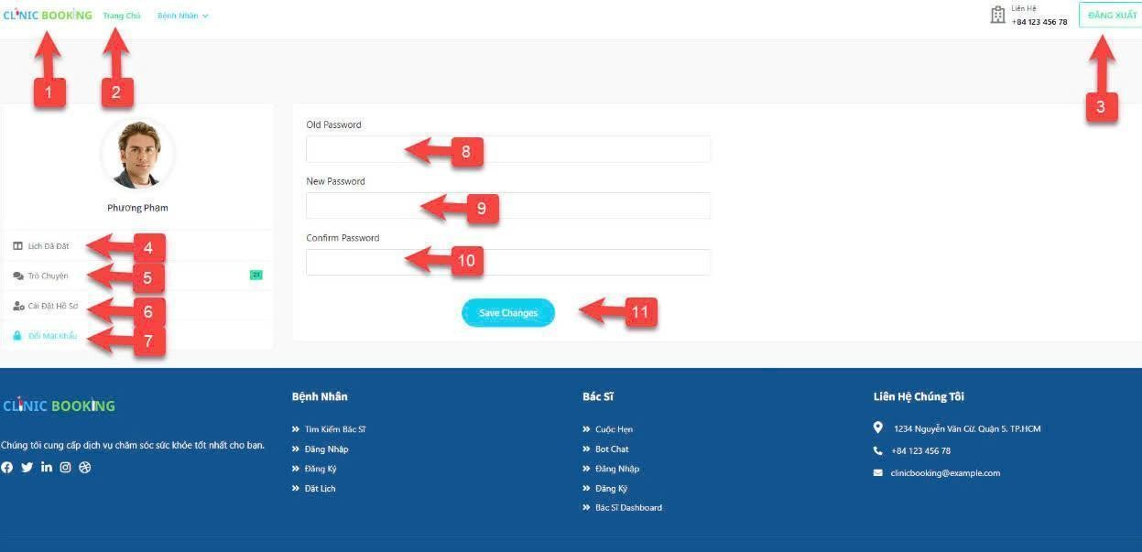
Figure 7: Change Password

ID | Condition | Control Type | Target | Notes
8 | Nothing | Text | Display information.
9 | Click | Button | Choose other functions.
10 | Click | Textbox | Input password.
11 | Click | Button | Save changes.

Table 7: Change Password

    - UI-08: Chat & Chatbot
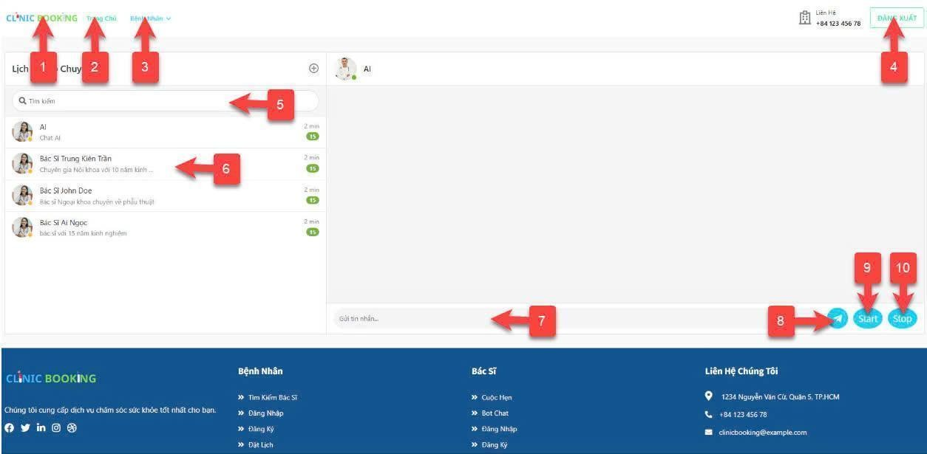

Figure 8: Chat & Chatbot

ID | Condition | Control Type | Target | Notes
1 | Click | Menu Button | Home | Navigate to the homepage.
2 | Click | Menu Button | Departments | Access the department section.
3 | Click | Menu Button | Patients | View or manage patient information.
4 | Click | Button | Logout | Log out of the system.
5 | Enter | Search Bar | Search Conversations | Search for a conversation.

6 | Click | List Item | Open Conversation | Select and open a specific chat.
7 | Enter | Textbox | Send Message | Type a message in the chat box.
8 | Click | Button | Send | Send the typed message.
9 | Click | Button | Start | Start a conversation session.
10 | Click | Button | Stop | Stop the conversation session.

Table 8: Chat & Chatbot

    - UI-09: Dashboard (Doctor).
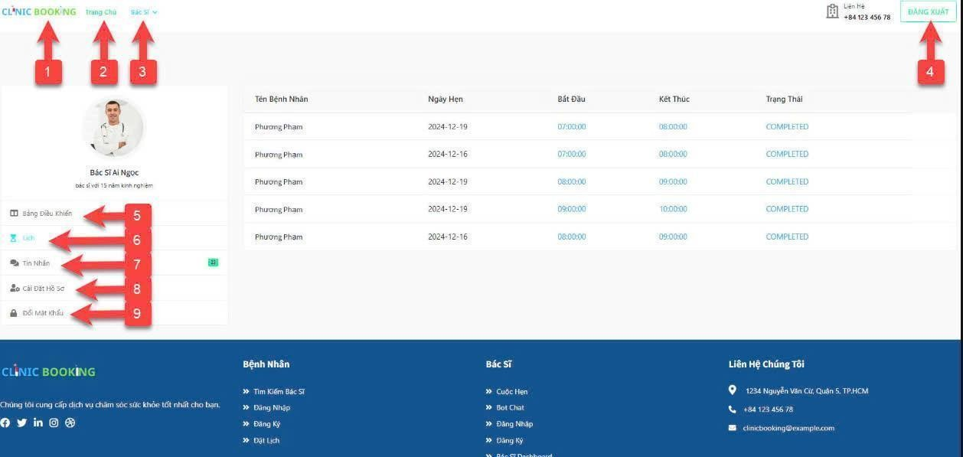

Figure 9: Dashboard (Doctor).

ID | Condition | Control Type | Target | Notes
1 | Click | Logo/Button | Home | Navigate to the homepage.
2 | Click | Menu Button | Departments | Access the department section.
3 | Click | Menu Button | Doctors | View or manage doctor profiles.
4 | Click | Button | Logout | Log out of the system.
5 | Click | Menu Button | Dashboard | Navigate to the dashboard.

6 | Click | Menu Button | Schedule | View and manage schedules.
7 | Click | Menu Button | Messages | Access and manage messages.
8 | Click | Menu Button | Profile Settings | Update profile information.
9 | Click | Menu Button | Change Password | Update account password.

Table 9: Dashboard (Doctor).

    - UI-010: Dashboard (Admin).
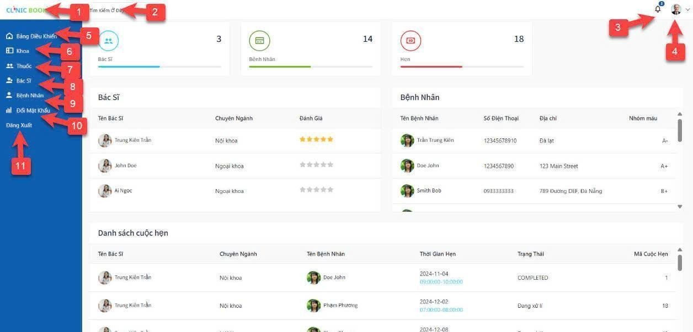

Figure 10: Dashboard (Admin).

ID | Condition | Control Type | Target | Notes
1 | Click | Logo/Button | Home | Navigate to the homepage.
2 | Enter | Search Bar | Search | Search for specific records or data.
3 | Click | Icon | Notifications | View system notifications.

4 | Click | Icon | Profile/ Account | Access the user account menu.
5 | Click | Tab | Doctors/ Patients Overview | View statistical data for doctors and patients.
6 | Click | Menu Button | Medicines | View and manage medicine records.
7 | Click | Menu Button | Doctors | Manage doctor profiles.
8 | Click | Menu Button | Patients | Manage patient profiles.
9 | Click | Menu Button | Appointments | View and manage appointment schedules.
10 | Click | Menu Button | Change Password | Update user account password.
11 | Click | Menu Button | Logout | Log out of the system.

Table 10: Dashboard (Admin).

    - UI-013: User account management (Admin).
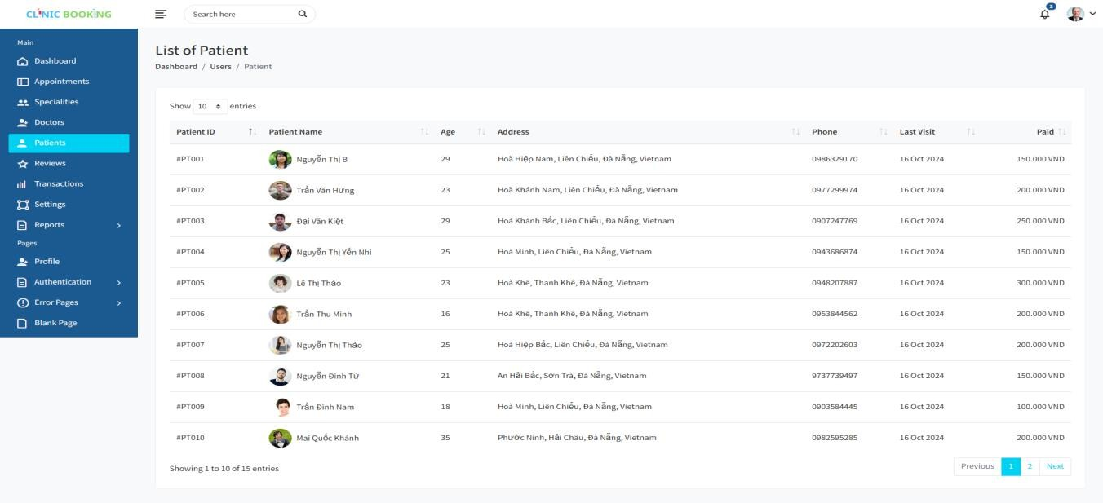

Figure 11: User account management (Admin).
ID | Condition | Control Type | Target | Note

1 | Click | Button | View dashboard
2 | Click | Button | View account.
3 | Click | Button | View events
4 | Click | Button | View profile
5 | Click | Textbox | Input data to search.
6 | Click | Icon | Search data.
7 | Nothing | Data Grid Field | View user information.
8 | Click | Icon | Edit information.
9 | Click | Icon | Delete users.
10 | Click | Icon | Go to next page,previous page.
11 | Nothing | Button | Logout account.

Table 11: User account management (Admin).

    - UI-014: Doctor management (Admin).
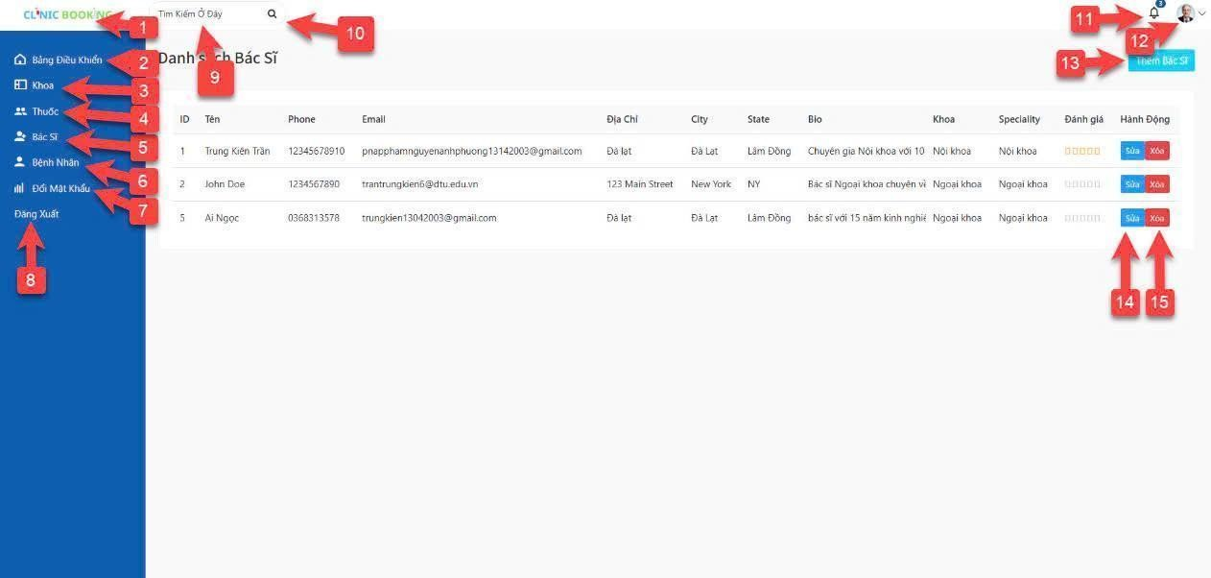
Figure 12: Doctor management (Admin).

ID | Condition | Control Type | Target | Note
1 | Click | Text | Dashboard

2 | Click | Text | Departments
3 | Click | Text | Medicines
4 | Click | Text | Doctors
5 | Click | Text | Patients
6 | Click | Text | Change Password
7 | Click | Text | Logout
8 | Click | Textbox | Search (input field)
9 | Click | Icon | Search button
10 | Click | Icon | Notifications
11 | Click | Icon | User profile
12 | Click | Button | Add Doctor
13 | Click | Button | Edit doctor

Table 12: Doctor management (Admin).

    - UI-015: Add department (Admin).
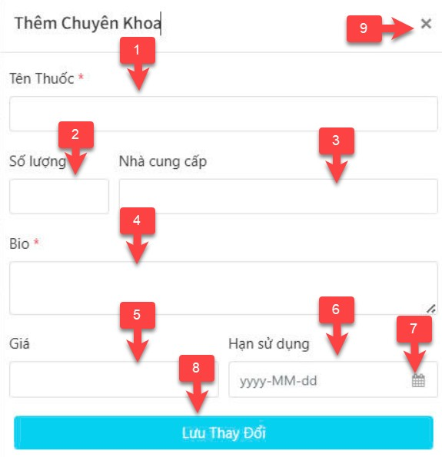
Figure 13: Add department (Admin).
ID | Condition | Control Type | Target | Notes

1 | Input | Textbox | Medicine Name | Input field for the medicine's name. Required field (indicated by asterisk).
2 | Input | Textbox | Quantity | Input field for the quantity of medicine.
3 | Input | Textbox | Supplier | Input field for the supplier's name.
4 | Input | Textarea | Description/ Bio | Text area for a description or bio of the medicine.  Required field (indicated by asterisk).
5 | Input | Textbox | Price | Input field for the price of the medicine.
6 | Select | Datepicker | Expiration Date | Date picker for selecting the medicine's expiration date. Requires multiple actions (click to open, select date).
7 | Click | Calendar Icon (Button) | Open Datepicker | Opens the calendar for date selection within the Expiration Date field. This is distinct from the date selection itself (ID 6).
8 | Click | Button | Save Changes | Submits the form to save the entered data. Tests should include successful and unsuccessful scenarios (e.g., missing required fields).
9 | Click | Close Button | Close Form | Closes the "Add Specialty" form or window.

Table 13: Add department (Admin).

2.1.13 UI-016: Add Medicine (Doctor).
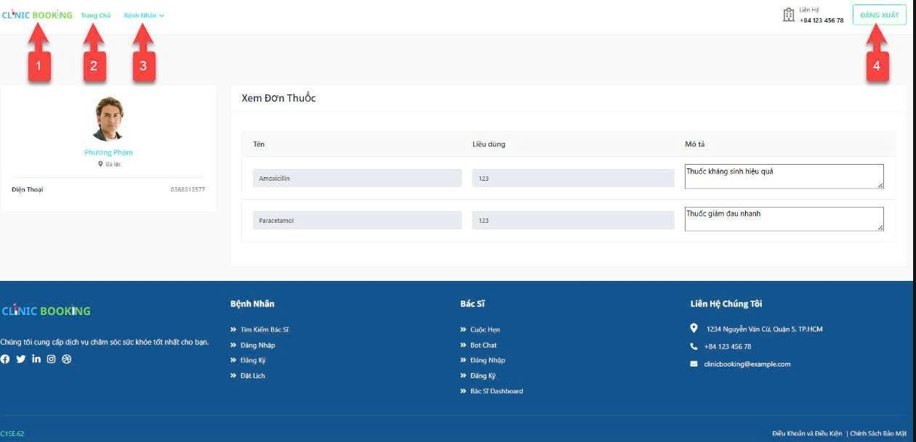

Figure 14: Add Medicine (Doctor).

ID | Condition | Control Type | Target | Notes
1 | Click | Logo/Button | Home | Navigate to the homepage.
2 | Click | Menu Button | Departments | Access the department section.
3 | Click | Menu Button | Patients | View or manage patient profiles.
4 | Click | Button | Logout | Log out of the system.
5 | View | Patient Profile | Display Patient Info | View the patient's personal details.
6 | View | Prescription | View Prescription Details | Display the details of medications.

Table 14: Add Medicine (Doctor).

